China Finance and Economic Review invites the submission of articles by both Chinese and overseas scholars.

**Editorial review and acceptance**

The acceptance criteria for all papers are the quality and originality of the research and its significance to our readership. Except where otherwise stated, manuscripts are peer reviewed by anonymous reviewers. Final acceptance or rejection rests with the Editorial Board, who reserves the right to refuse any material for publication.

Manuscripts should be written so that they are intelligible to the professional reader who is not a specialist in the particular field. They should be written in a clear, concise, direct style. Where contributions are judged as acceptable for publication on the basis of economic, the Editor and the Publisher reserve the right to modify typescripts to eliminate ambiguity and repetition and improve communication between author and reader. If extensive alterations are required, the manuscript will be returned to the author for revision.

**Submission of manuscripts**

Manuscripts should be submitted via email in MS-Word (doc) format to the Editor, cfer@cass.org.cn

**Example:**

**Poverty AlleviationEffect of Chinese Aid and Investment in “the Belt and Road”**

Zhang Yuan**[1]\***

China contributes to poverty alleviation in developing countries along “the Belt and Road (B&R)” by the way of aid and investment, taking infrastructure construction as a breakthrough and state-owned capital as the main force. The empirical study of the B&R countries’ panel data of 2000~2017 shows that Chinese aid and investment help to reduce poverty rate, and there is a threshold effect between investment and poverty rate. When the per capita GDP level is below the threshold value, the poverty reduction effect of Chinese investment is more significant. Different types of aid and investment generate different poverty reduction effects: construction project investment and green land investment have more significant effects, and poverty reduction mechanism based on infrastructure construction has better poverty reduction effect than transfer payment aid. The correlation between state-owned enterprise investment and poverty rate is significant, and state-owned capital plays an important role in poverty reduction in the B&R developing countries. The research also finds that poverty reduction effect of Chinese aid and investment is realized mainly by capital formation and job creation in these countries.

**Keywords**: foreign aid, investment, poverty reduction, the Belt and Road

**1. Introduction and literature review**

Since the 1980s, along with the promotion of reform and opening-up and the implementation of large-scale poverty alleviation plan, China has achieved significant achievement in poverty reduction

……

**2. The mechanism of poverty alleviation of Chinese aid and investment in “the Belt and Road”: statistical observation**

*2.1 Promoting poverty reduction through aid and investment at the same time*

China has a long history of helping the developing countries that along “the Belt and Road”.

……

2.1.1 Joint mechanism of government and market

It is due to the large demand of infrastructure, high difficulty

……

(1)

……

Table 1.The Statistical Description of Main Variables

|  |  |  |  |  |
| --- | --- | --- | --- | --- |
| Variables | Connotation | Oberservedvalue | Mean | Standard deviation |
| *Debt* | Debt balance | 390 | 2.889 | 2.513 |
| *Exdebt* | Explicit debt balance | 389 | 2.643 | 2.224 |
| *Hidebt* | implicit debt balance | 390 | 1.931 | 2.386 |
| *Gap* | Output gap | 390 | –11.74 | 19.74 |
| *Press* | Promotion pressure | 390 | 1.585 | 0.885 |
| *Credit* | Loan balance of regional financial institutions | 390 | 8.973 | 1.046 |
| *Land* | Land transfer income | 390 | 5.396 | 1.739 |
| *lrengdp* | GDP Per capita | 390 | 9.980 | 0.741 |
| *linvest* | Investment in fixed assets | 390 | 8.452 | 1.297 |
| *quekou* | Fiscal gap | 377 | –0.105 | 0.081 |

……

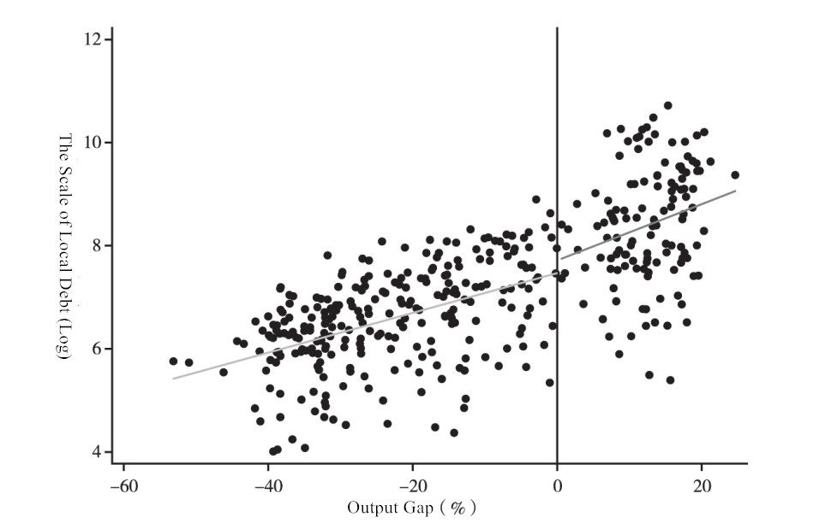

Figure 2. Output gap and local debt scale

……

**Reference:**

Bai,Y. (2015).Initiative of “one Belt and Road” and the transformation of China's foreign aid.*World Economics and Politics (ShijieJingjiyuZhengzhi),* 11, 53-71.

Banik, D. (2013).China's Aid and Poverty Reduction in Africa.In Guanghua Yu (eds.), *Rethinking Law and Development: the Chinese Experience*, London: Routledge.

Barthel, F., Neumeyer, E., Nunnenkamp, P., &Selaya, P. (2014).Competition for Export Markets and the Allocation of Foreign Aid: The Role of Spatial Dependence among Donor Countries.*World Development*, 64(1), 350-365.

参考文献按照APA格式，按字母顺序排序

中文参考文献期刊名翻译为英文，并在括号中加中文期刊名拼音

**Manuscript Format and Style**

**Parts of the Manuscript**

Manuscripts should be presented in the following order: (i) title page, (ii) main text, (iii) referecnes, and (v) appendices.All tables and figures need to be inserted in the related text. Figures and supporting information are also required to be supplied as separate files.

**Title page**

The title page should contain:

1. a short informative title. The title should not contain abbreviations
2. authors’ name
3. an abstract of no more than 150 words
4. key words (3-5)
5. JEL codes (2-4)
6. Authors’ position at relevant affiliation (e.g. Associate Professor), complete affiliations, and email address should be provided as a footnote on the title page

**Acknowledgements**.The source of financial grants and other funding should be acknowledged. The contribution of colleagues or institutions should also be acknowledged. Thanks to anonymous reviewers should not be included. Acknowledgementshould be provided as a footnote on the title page.

**Abstract, Keywords, and JEL codes.**All articles must have a brief abstract that states in 150 words or fewer the major points made and the principal conclusions reached. The abstract should not contain abbreviations or references.

Below the abstract a list of three to five keywords (for the purposes of indexing) should be supplied in alphabetical order.

Please include three or four JEL codes after the abstract (see

http://www.aeaweb.org/jel/guide/jel.php for further information).

**Main text**

The text should be organized into an introductory section, conveying the background and purpose of the report, and then into sections identified with subheadings.

Subsections should be numbered1.1 (then 1.1.1, 1.1.2, ...), 1.2, etc. (the abstract is not included in section numbering). Use thisnumbering also for internal cross-referencing: do not just refer to 'the text'. Any subsection may begiven a brief heading. Each heading should appear on its own separate line.

**References**

*Citation in text*

Please ensure that every reference cited in the text is also present in the reference list (and vice

versa).The Harvard (author, date) system of referencing is used (examples are given below).

• In the text give the author’s name followed by the year in parentheses: Smith (2000).  
• If there are two authors use ‘and: Baskin and Baskin (1998)  
• When reference is made to a work by three or more authors, the first name followed by *et al.*should be used: MacDonald *et al.* (2002).  
• If several papers by the same authors and from the same year are cited, a,b,cetc should be inserted after the year of publication.

*Reference list*

The reference list should follow the APA (American Psychological Association) format (examples are given below).

• References should be listed in alphabetical order.

• In the reference list, cite the names of all authors when there are six or fewer; when seven or more, list the first three followed by et al.

• Reference to unpublished data and personal communications should not appear in the list but should be cited in the text only (e.g. Smith, 2000, unpublished data).

• Authors are responsible for the accuracy of the references.

Examples:

*Journal articles*

Dietzenbacher, E., Pei, J., & Yang, C. (2012).Trade, Production Fragmentation, and China's Carbon Dioxide Emissions.*Journal of Environmental Economics & Management,* 64(1), 88-101.

*Online Article Not Yet Published in an Issue*

An online article that has not yet been published in an issue (therefore has no volume, issue or page numbers) can be cited by its Digital Object Identifier (DOI). The DOI will remain valid and allow an article to be tracked even after its allocation to an issue.

Murphy, K., Tyler, T. R.,& Curtis,A.(2009).Nurturing Regulatory Compliance: Is Procedural Justice Effective When People Question the Legitimacy of the Law?*Regulation & Governance* [online; cited date]. Available from:10.1111/j.1748-5991.2009.01043.x.

*Book*

Fujita M.,Krugman, P., &Venables,A. (2001).*The Spatial Economy: Cities, Regions, and International Trade*. Cambridge, MA: MIT Press.

*Chapter in a Book*

Anderson, K. &Tyers,R.(1990). “How EevelopingCountries Could Gain from Agricultural Trade Liberalization in the Uruguay Round,” in Goldin, I.&Knudsen,O.eds, *Agricultural trade liberalization: Implications for developing countries*, Paris: Organization for Economic Co-operation and Development, pp. 387-424.

**Footnotes.** Footnotes should be numbered in a list and referred to in the text with consecutive, superscript Arabic numerals. Keep footnotes brief: they should contain only short comments tangential to the main argument of the paper and should not include references.

**Appendices.** These should be placed at the end of the paper, numbered in Roman numerals and referred to in the text. If written by a person other than the author of the main text, the writer’s name should be included below the title.

**Tables.** Tables should be self-contained and complement, but not duplicate, information contained in the text. Number tables consecutively in the text in Arabic numerals. Type tables on a separate page with the legend above. Legends should be concise but comprehensive – the table, legend and footnotes must be comprehendible without reference to the text. Vertical lines should not be used to separate columns. Column headings should be brief, with units of measurement in parentheses; all abbreviations must be defined in footnotes. Footnote symbols: †, ‡, §, ¶, should be used (in that order) and *, **, *** should be reserved for p-values. Statistical measures such as SD or SEM should be identified in the headings.

Example:

Table 1.The Statistical Description of Main Variables

|  |  |  |  |  |
| --- | --- | --- | --- | --- |
| Variables | Connotation | Oberservedvalue | Mean | Standard deviation |
| *Debt* | Debt balance | 390 | 2.889 | 2.513 |
| *Exdebt* | Explicit debt balance | 389 | 2.643 | 2.224 |
| *Hidebt* | implicit debt balance | 390 | 1.931 | 2.386 |
| *Gap* | Output gap | 390 | –11.74 | 19.74 |
| *Press* | Promotion pressure | 390 | 1.585 | 0.885 |
| *Credit* | Loan balance of regional financial institutions | 390 | 8.973 | 1.046 |
| *Land* | Land transfer income | 390 | 5.396 | 1.739 |
| *lrengdp* | GDP Per capita | 390 | 9.980 | 0.741 |
| *linvest* | Investment in fixed assets | 390 | 8.452 | 1.297 |
| *quekou* | Fiscal gap | 377 | –0.105 | 0.081 |

**Equations.** Equations should be numbered sequentially with Arabic numerals; these should be ranged right in parentheses. All variables should appear in italics. Use the simplest possible form for all mathematical symbols.

**Figures.** All illustrations (line drawings and photographs) are classified as figures. Figures should be cited in consecutive order in the text.

Please provide the figures as Excel files. If Excel files are not possible, figures must be supplied as high resolution (at least 300dpi) files.

Example:



Figure 2. Output gap and local debt scale

1. * Yuan Zhang (email: abc@sina.com), Associate Professor in China University of Labor Relations. Fund projects: National Social Science Fund “Research on Liquidity Risk and Optimum Classified Management Model of China’s Foreign Exchange Reserve” (17BJY199).